May 13, 2020

Dear 12th-grade students and families,

I hope you all are staying well during these unparalleled times.

Today, I write to share some more news around our plans as a School District to honor our graduating seniors, and provide you with the necessary resources to ensure that your transition during these next few months is a seamless one.

Virtual Graduation
Save the date: I invite you and your families to participate in a District-wide virtual graduation on Tuesday, June 9 at 11 a.m.

Students are also invited to a 90-minute dance party, to be live-streamed from 7 p.m. to 8:30 p.m. and hosted by popular DJs, also on June 9. There will be surprise live performances, celebrity shout-outs, and real-time, interactive opportunities for our seniors to engage with one another during this experience.

While we realize that no virtual program will ever replace live, iconic senior year experiences such as prom and graduation, we recognize how important it is to do what we can during these difficult times to honor your achievements. You have worked hard and deserve to feel celebrated and valued as you close out your time as a high school student!

Next week, you will receive customizable invitations to our virtual graduation, which you are encouraged to share with your families and friends so that they can participate in this experience as well.

We also plan to celebrate the Class of 2020 with social media and advertising campaigns, celebratory efforts throughout the City, and much more. Please stay tuned as we unveil new surprises each week!

Senior Hotline
I also want to share that the District’s Offices of Postsecondary Readiness and High School Supports have launched a senior hotline to provide seniors with additional support while school buildings are closed.

The hotline operates from 11 a.m. to 1 p.m. Tuesdays through Thursdays, and is staffed by District college, career and technical education experts.

Participating staff will be able to provide live support on pursuing postsecondary opportunities, connect you with school-based counselors, guide you through college enrollment or application paperwork, and assist with completing FAFSA applications and/or verification.

The hotline is available by phone at 215-400-4130 and by email at collegeandcareer@philasd.org. A language line will also be available to support non-English speakers. More information can be found online at philasd.org/collegeandcareer.

Access to School Buildings
Many students and families have been asking when they will be allowed back in school buildings to retrieve personal items, return textbooks and uniforms, and obtain items such as caps and gowns and yearbooks that were received before buildings were closed. While we understand and appreciate the need to perform these end-of-year activities, we must continue to make decisions in the best interests of everyone’s safety and well-being.

As a result, our school buildings will remain closed until the City’s shelter in place order has been relaxed. No in-person activities of any kind are permitted in school buildings or on school property at this time. In addition, to follow the City’s guidance on minimizing non-essential travel, schools should not arrange for events (e.g. yearbook pick-up) at alternative locations or organize “traveling” graduations. We will update you on the plan to re-enter school buildings once it is safe to do so.

Though this year’s graduation and celebratory activities may look and feel a bit different, we want to ensure your years of hard work and perseverance are honored. Congratulations on becoming a School District of Philadelphia Class of 2020 graduate! We all look forward to safely celebrating with you in the coming weeks and updating you as our plans progress.

In the meantime, please take care and stay safe.

Sincerely,
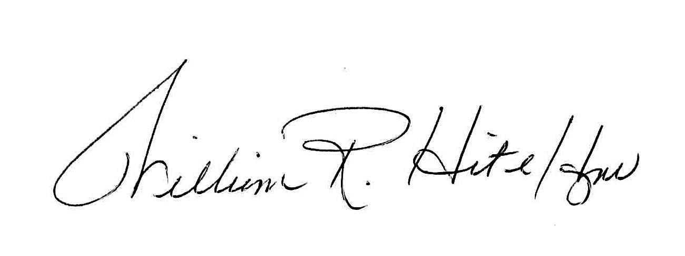
William R. Hite Jr., Ed.D.
Superintendent
The School District of Philadelphia

